|  |
| --- |
| PHYS1521  **Math and Physics for Games**  Project Report  Digital Media and IT  School of Applied Sciences and Technology |

|  |  |
| --- | --- |
| **Name(s):** | James Marr |
| **Section:** | DMIT 1521 Math and physics for games |
| **Date:** | April 25, 2025 |
| **Instructor:** | Kyle Kulyk |

Table of Contents

Introduction 1

Overall project setup 2

HardCoded 5

ForceCoded 7

CodePhysics 8

Conclusion 10

References 11

**Table of Figures**

Figure 1. Game Enviroment 2

Figure 2. GameState Code 3

Figure 3. PlayerController Variables, Awake and update 3

Figure 4. PlayerController Trigger Methods 3

Figure 5. PlayerController FixedUpdate universal 3

Figure 6. Wall Code 4

Figure 7. HardCode code 5

Figure 8. HardCode Gif Example 5

Figure 9.SmashBros (Nintendo, n.d.) PlatformExample 6

Figure 10. ForceCoded Code 7

Figure 11.ForceCode Gif Example 7

Figure 12. CodedPhysics code 8

Figure 13.CodePhysics Gif exmaple 8

# Introduction

For this research project, I have chosen to utilize my knowledge of math and physics in a unity game framework by creating multiple code types on how physics can be handled in programing. The types that will be covered in this report will be:

1: HardCoded: Implementation of all physics on a rudimentary level that is enough to work on close enough to the other coded types.

2: ForcePhysics: Utilizing unity’s physics engine built in and applying forces to the player object.

3: CodePhysics: Also utilizing unity’s physics engine but applying different methods of movement that aren’t applying forces.

These names for each type of physics used are self-named to keep track for the type of physics that will be talked about during this report.

The reason why I’ve chosen this as my research project is that I’ve always been interested in the various types of ways that movement is handled in various games. There are always advantages and disadvantages to each individual type a developer decides to choose for their game. I wanted to explore in depth for some of the shortcomings that each style has, well also learning some unique ways that can be done to overcome these challenges.

# Overall project setup

The setup of the project will be using Unity 6000.041f1 (Unity, n.d.) for the game engine used for this project, Visual studio 2022 (Microsoft, n.d.) v17.13.2 with C# as the coding base being used, the base project template will be using the universal core 2D template, most game objects used in the scene will contain an appropriate collider (e.g. box collider2D), rigidbody2D and a capsule represented as a player. In the GameState object it will contain the state of which physics type/modes that are being used at any given time. (HardCoded, ForcePhysics, CodePhysics) Each of the individual modes will influence some physics objects by changing their body type so that each of the individual physics will minimally affect the other modes, for example the left and right wall will switch on its trigger on their respective colliders well in HardCoded mode but turn it off well in any other mode.

The setup of the game scene will have 2 walls, a ground, a platform, a red trigger box that will work as a force to push left labeled “ConveyorBelt”, the scene camera and the Player capsule. By using unity’s new InputSystem, the player can move left, right and jump, this will allow the player to interact with the scene and the various objects. The majority of all the code that will affect the player will be in the “PlayerController” script to reduce the need of applying a lot more code across the setup project as a whole. Notable exceptions of what objects also have code are the walls to switch the collider triggers on and off based on the current mode. Each of the physics modes that affect the player will be split into a switch statement in FixedUpdate with a universal grounded check and a horizontalMovement variable.



Figure . Game Enviroment

Universal Code Aspects:

GameState:

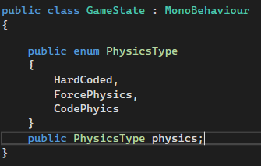

Figure . GameState Code

PlayerController:

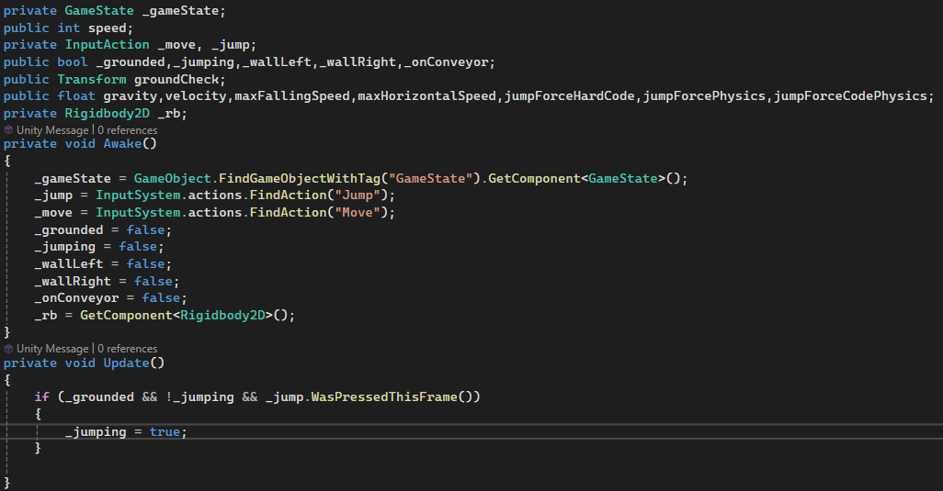

Figure . PlayerController Variables, Awake and update

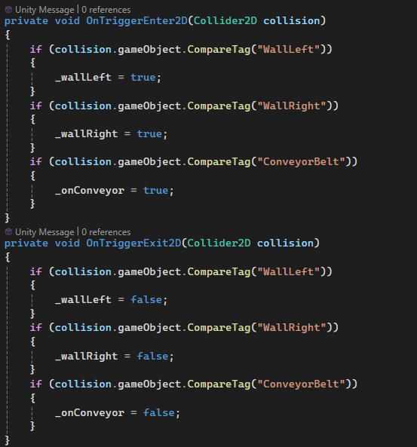

Figure . PlayerController Trigger Methods



Figure . PlayerController FixedUpdate universal

Walls:

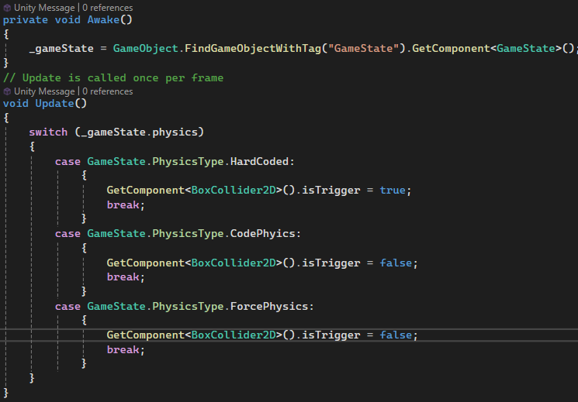

Figure . Wall Code

## HardCoded

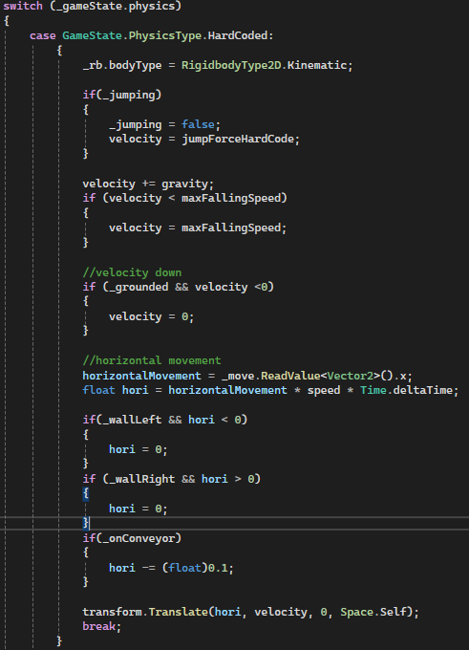

Figure . HardCode code



Figure . HardCode Gif Example

In the above Gif figure is a showing of the HardCode mode in action. The amount of code needed to get this type of style working is more than what is required of the other 2 code types in this project. Considering how the player interacts with the environment, it requires much more additional code to achieve the same level as the built-in unity physics engine.

The player will always be affected by gravity or transform.Translate in all situations, but when in a grounded state, their velocity before applying the transform.Translate is set to 0 if it even goes into the negative to simulate normal force of objects holding an object up. This type of method for controlling gravity when someone understands how much speed an object should be accelerating downward on the given situation is easy to pull off but has some interesting issues that arise when dealing with various objects in different ways.

One of the noteworthy downsides with this mode of physics is that you need to accommodate all interactions within the engine. Things like walls need to have additional checks for which direction they collide with and how a player should interact with it. This then has the downside because when a player manages to not be within the confines of the environment, many things don’t work as intended.

Another noteworthy downside is the fact that because of the use of transform.Translate in this example, the player will always phase through objects that don’t have accommodated variables. In the above gif example, the player can be observed to be able to jump up through the platform. Depending on which style of game you develop, this is either a good or a bad thing. Platform fighters for example allow the player to jump up through platforms and drop down based on player input, this has strategic advantages as part of the gameplay.

Figure .SmashBros (Nintendo, n.d.) PlatformExample

## ForceCoded

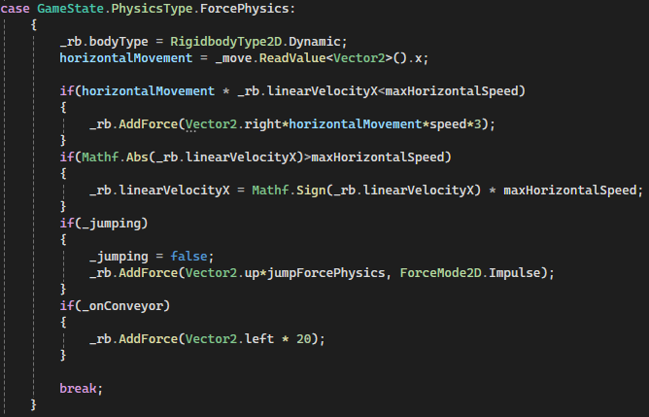

Figure . ForceCoded Code



Figure .ForceCode Gif Example

The above Gif shows the ForceCoded in action. For this style of coding, the amount needed to work within the unity engine is much smaller than the HardCoded mode. This is one of the specific advantages that comes with using a game engine over things like frameworks since there are many useful tools like their built-in physics engine.

One aspect of using only forces to move around objects/players is there are still many backend variables you have got to keep track of. Things like the friction and mass of the player, the objects and many more things that will interact need to be worked with. There is a layer of abstraction with the developer when using the engine if they are unaware how the backend code works. So many layers of adjusting are required to get desired output.

Because unity handles all the physics interactions, it will also shift objects away to the appropriate distance away if their collider and rigid body is set correctly. This reduces the need to figure out the exact distance objects need to be apart, this has an advantage over the HardCoded variation where because of frame inconsistencies, this prevents the player from phasing partially (if fast enough, completely through) into the ground and then having to readjust the player manually up to the appropriate height.

## CodePhysics

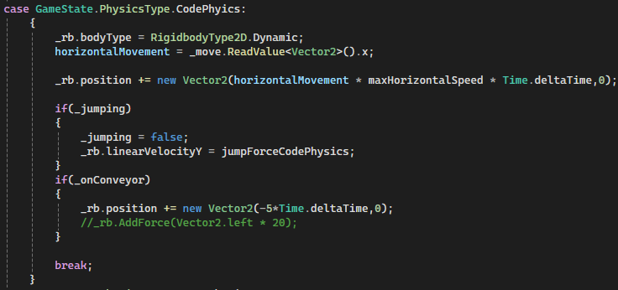

Figure . CodedPhysics code



Figure .CodePhysics Gif exmaple

The above Gif shows CodePhysics mode in action. Similar to ForcePhysics the amount of code needed to work within the unity engine is much less than the HardCoded mode. With specific advantages to not needing to add checks to various objects and code, it relies on the system and set up of the environment to do all the work.

When it comes to jumping, because of this style of coding allowing you to set the velocity that the object will take, this allows developers to have much more control on how much height the player will achieve regardless of the mass. Compared to using force to do this, the developer would have to adjust both the amount of force put into the object and the mass to get a desired result. This can allow the developer to adjust the mass with other interactions without needing to readjust the jumping height to keep consistent across the development process.

The added benefit of using movement through the rigidbody2D, is still possible to add in forces from various sources. The “ConveyorBelt” can be coded to either move the player with rigibody.Position or rigidbody.AddForce, it’s also possible to code it by applying the velocity to a specific value well in the ConveyorBelt. Each have their own unique interactions on the player, so the desired outcome of a developer on which one they choose can vary.

Notable use cases reasons for each:

Position: The position allows for instant movement without any alteration to the desired player direction.

AddForce: The adding of force to an object gives situations where there is always a slight delay with getting to the desired speed in a given direction. Many games use this “delayed” control in various game challenges for the player to overcome.

LinerVelocity: Liner velocity on the rigidbody allows for a much different kind of control. Human bodies can dampen and provide acceleration in many different directions because of how we use our body parts as dampeners or recoiling springs well not normally acknowledging were applying forces. So, this style of movement mimics more closely to how a human would walk around and how we are still utilizing the velocity of our body against other objects but also allowing other forces to still interact with us.

# Conclusion

In conclusion, there are many ways for a developer to program movement into a game. Each have their own upsides and downsides. In some cases, the developer might choose to utilize the built-in physics engine, in others they might choose to implement their own version for better control or need a different kind of physics reaction that wouldn’t be covered in the engine.

I’ve personally found many kinds of new interactions that will allow me to create new game mechanics. One such example is understanding the different ways of acknowledging platforms to utilize them differently than just a physical object that exists in a game world that needs to be worked around. Another example is depending on how a player stays in a zone that accumulates force but using a movement system that doesn’t affect the velocity normally can create movement in a unique way separately from a normal situation.

Many of these applications of physics in this research project all stem from general basic knowledge of math and physics, specifically in a game engine environment. This research topic on different ways to program movement in games is something that would fit well into PHTS 1521 because of the amount of physics that a developer could wish to program into a game.

# References

Microsoft. (n.d.). *Visual Studio*. Retrieved from Visual Studio: https://visualstudio.microsoft.com/

Nintendo. (n.d.). *Super Smash Bros*. Retrieved from Super Smash Bros: https://www.smashbros.com/en_US/

*Unity*. (n.d.). Retrieved from Unity: https://unity.com/